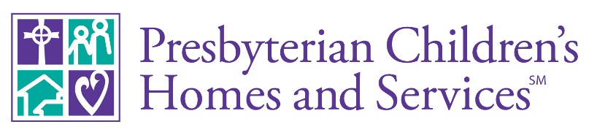
Seeking a
Early Childhood Specialist – Corsicana, Texas

To provide strength based, family focused, and goal driven child and family services to families with children ages 0-5; promote attachment, engagement and healthy child development with families; work with and collaborate with other community agencies serving this age group; participate, plan and help facilitate parent support and education groups; provide awareness to individual families and the community regarding prevention of child abuse and neglect and child well-being; nurture, develop, and organize community resources as needed.
This position reports directly to the Early Childhood Supervisor.

Core Responsibilities
- To be knowledgeable of local needs and available services to children and families in the community.
- To publicize Hopes Program presence; serve as a professional liaison with the local social service community; and participate in community events and awareness campaigns.
- To work with Hopes leadership in promoting recruitment and general public awareness of child well-being and decrease of child abuse and neglect.
- To receive referrals and maintain a caseload of 15 families, make home visits, conduct need assessments, develop a plan of service that is culturally sensitive and promotes self-determination for the family. Explore and facilitate referrals as appropriate to the needs and abilities of the family.
- To assist in facilitating parenting groups or public awareness events to meet the program goals of child well-being and decrease of child abuse and neglect.
- To practice with a family centered, strength focused and goal driven approach while utilizing the PCHAS Way.
- To assist and encourage families to advocate and coordinate (within their capacity) all needed services for themselves.
- To coordinate services for children and their families according to the service plan and best practice standards.
- To consistently reevaluate the plan of service as goals are accomplished and/or changed.
- To maintain all documentation in the case record in CSWIS and provide PIERS data in an ethical and timely manner.
- To collaborate, communicate with and assist Hopes leadership in order to provide the best possible early childhood resources.
- To participate in linkages by referring and accepting referrals with PCHAS Child & Family Program in an effort to promote internal wrap around services.
- To attend Hope meetings, participate in quality assurance teams as assigned and travel for training as needed.
- To receive reflective supervision from the Early Childhood Supervisor twice per month and participate in group supervision as scheduled while working cooperatively as a Hopes team member.
- To receive leadership, guidance and service type training from the Hopes Program Director and Early Childhood Supervisor and participate cooperatively in communication, meetings and trainings as arranged.
- To perform other duties as assigned.

Working Conditions
Hopes Program will provide normal office equipment (computer, copier, office furniture). Much of the work week is spent outside the office doing home visits, face to face contact with clients, resource networking and recruiting. Reliable transportation is a necessity and overnight trips may occasionally be necessary for training, quality assurance and Regional meetings. Evening and weekend hours will be required as needed to meet the needs of client schedules and community events.

Job Requirements:
This position requires education, training and experience in human service delivery to families. The ability to work with a wide variety of human problems and competence in handling crisis intervention is required. Flexibility in terms of work hours is necessary and will necessitate some evening and weekend hours to meet the needs of working families. Possessing excellent interpersonal skills with children and their families is essential along with strong organizational skills, time management, and flexibility in scheduling. This position requires a highly motivated self-starter with special abilities to relate to families with young children, existing social services and community groups.

Desired job expectations:
- LBSW or Bachelor degree in a related field.
- Two year experience working with children and their families is preferred.
- Licensure is preferred.
- Experience and excellent skills in engaging with families and social service agencies.
- Good listener and communicator both verbally and in writing.
- Possess critical thinking skills to help families to develop goals, find solutions and attain healthy outcomes for their young children
- Ability to effectively teach parenting techniques, model these techniques and observing parents demonstrate these new skills with their young children.
- Commitment to the Hopes program and families being served.
- Experience working in social services, the child welfare system or related experience working with parents and children.
- Extensive knowledge of local area social services, networking opportunities and recruiting strategies for receiving referrals.
- Bilingual

This is a 100% grant funded position. Although the grant is expected to end at some point in the future, it may be extended by the granting agency for an additional time period beyond that date. If that would occur, your employment under the grant may also be extended. However you should be aware that your employment as a staff member of Presbyterian Children’s Homes and Services is considered to be at will and may be terminated by you or PCHAS at any time regardless of the end of the grant.

Presbyterian Children’s Homes and Services is a faith-based Christian organization. We provide Christ-centered care and support to children and families in need. We strive to serve like Jesus. We meet our clients where they are and treat them with respect. We focus on our clients’ strengths rather than their problems. And we encourage our clients to focus on their future rather than their past. When we do this well, we help our clients find hope and know the love of God.

Apply online at pchas.org

