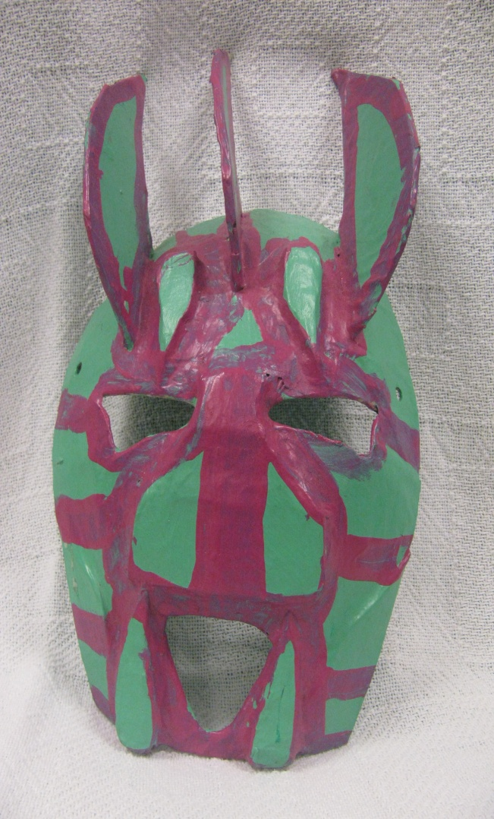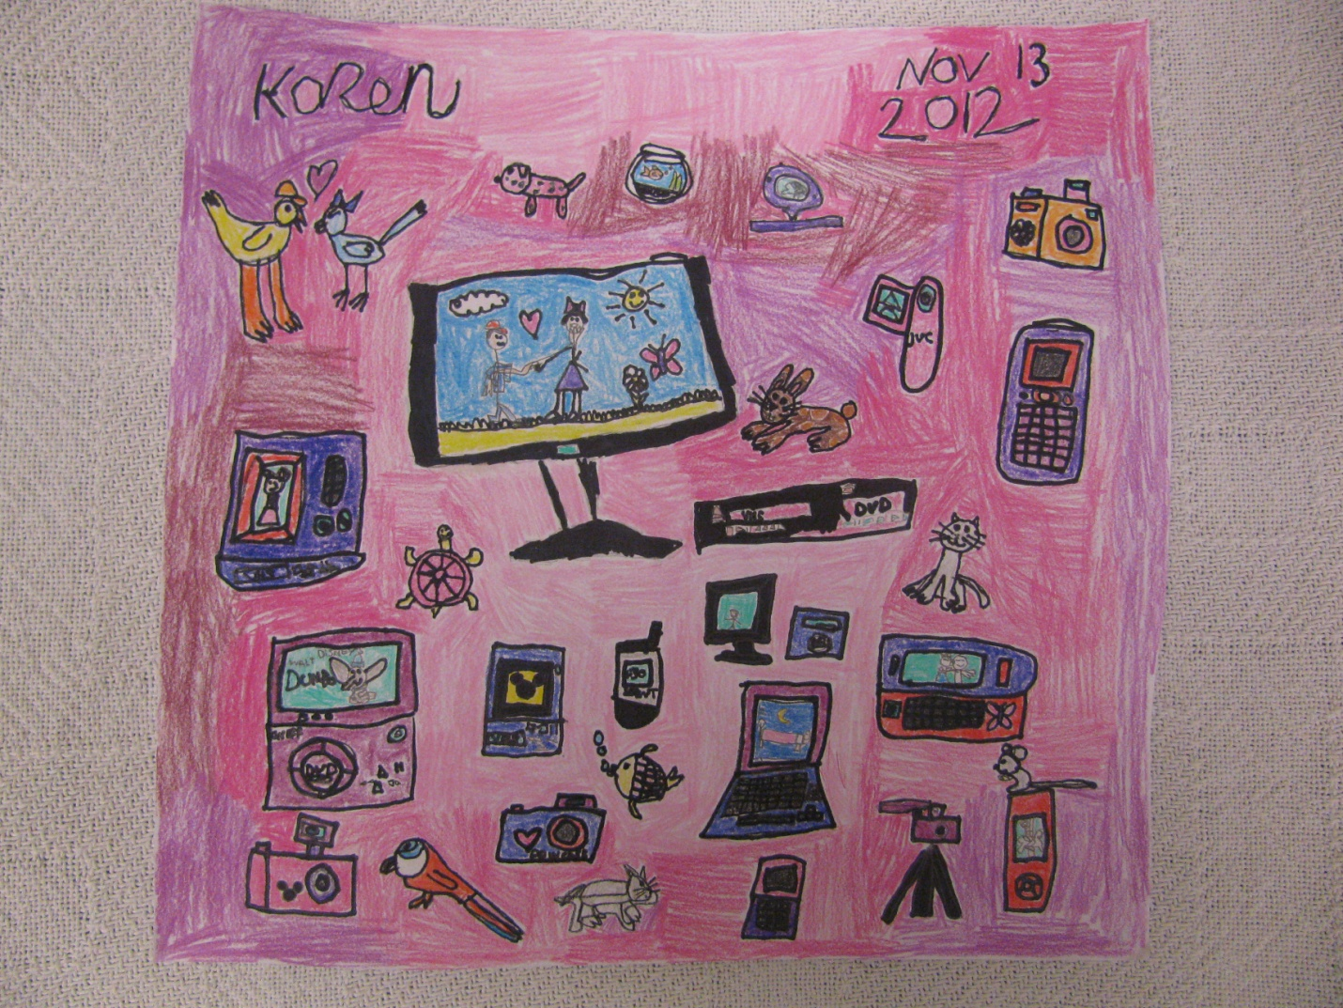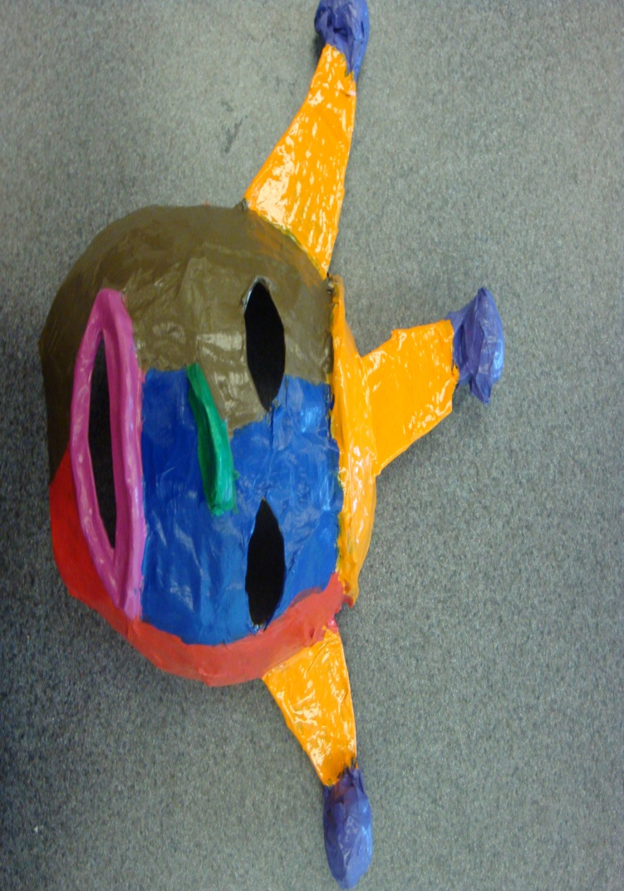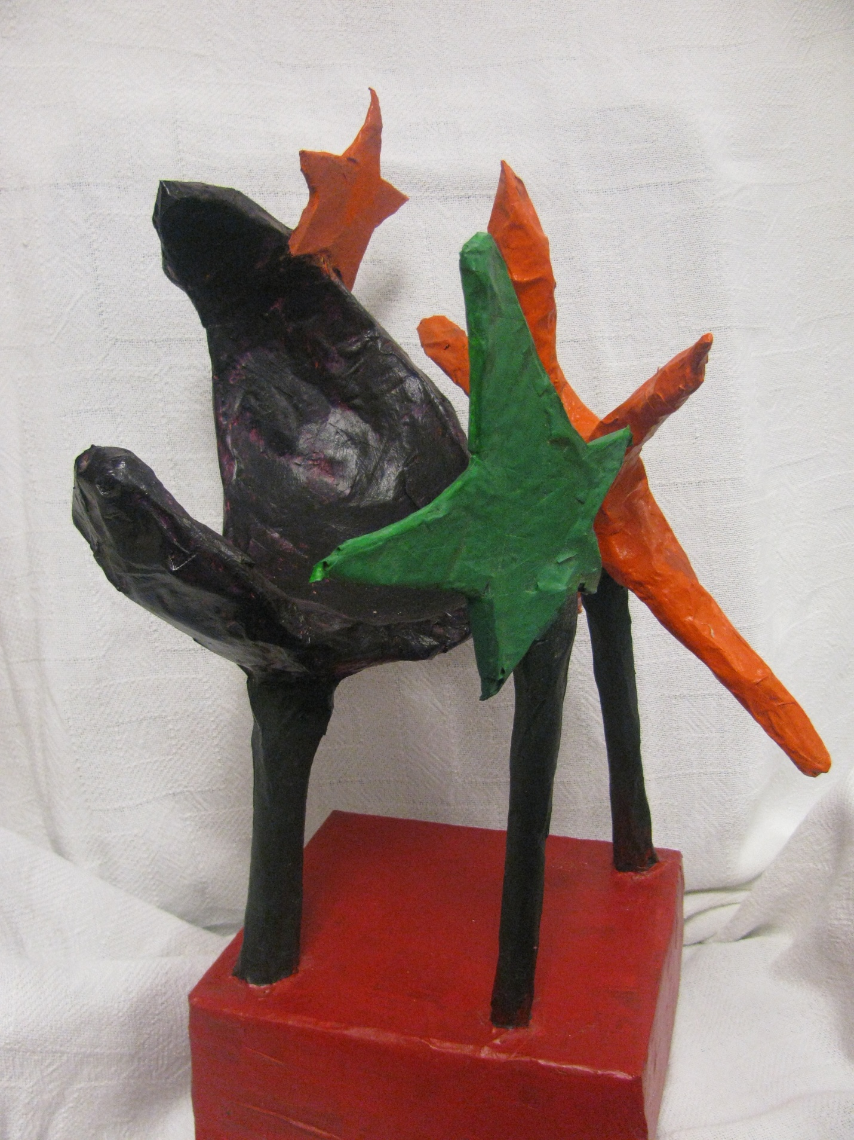

Understanding Disabilities Through Children’s Art

Artwork on cover from University High Students, Waco, Texas: Devin (top left), Karen (top right), Taeler (bottom left), Jesus (bottom right)

Art is a window into the world of a child with a challenge.
In this exhibit you are invited into the perceptions of the artists. The artists in this exhibit are all children with different intellectual or physical disabilities which can be a challenge in school and with their ability to relate to other children. When you walk with them and see the world through their eyes, it is our hope that your own children can reach out to them and possibly be their friends. The hearts of children with intellectual or physical disabilities want the same basic things and struggle with the same things as any other child; they just do so with a specific challenge, whether that is Down syndrome, Asperger’s syndrome, Attention Deficit Hyper Activity Disorder, Deafness, Seizure Disorder, Dyslexia, and Autism.

To Parents
There are three ways to view this exhibit:
- You can simply admire the art of the children.
- You can walk with your children and engage them in discussion of the art as art.
- You can engage your child to see into the world of the artist. It is very possible that your child has a classmate who struggles with one or more of these challenges. By understanding his or her special abilities; you can discuss with your child what it might be like to have different challenges and if your child can identify some of the differences in the picture that reflect the world of the artist.

Engaging this exhibit through the eyes of the artist.

The Art

The mainstreaming of today’s schools means that the classroom reflects a very wide array of learning styles as well as physical challenges. You and your children probably know children with challenges, some may see as significant. Getting to know other kids can seem to be a challenge, however, art offers a window into the life of the artist. When an artist draws a picture, like sewing a quilt or molding a pot out of clay, she or he starts with the assembly of the materials, paint, chalk, bits of paper, or brushes depending on the type of art. These elements are just things until they are drawn together in both the mind of the artist using his or her skills on the canvas. Thus the picture reflects the images of thoughts of the artist.

Picture Organization

Every child, including the artists in this exhibit, is given a slightly different set of skills and challenges. Each child is simply a gift with different abilities. It is also critical to understand that there are mild to severe challenges associated with each type of challenge, each child is unique. Some artists are challenged by things that affect their minds; others have to cope with physical challenges.

The pages that follow organize the pictures in the exhibit by the challenge of the artist so that viewers can better understand the challenges and strengths of the artist. When discussing these pictures remind your children of two things: those children with disabilities such as these have more strengths than deficits and more similarities to your child than differences. The definitions for the various disabilities are written in a manner that is readable to children but you may choose to adjust the wording depending on your child’s developmental phase of life.



Dyslexia

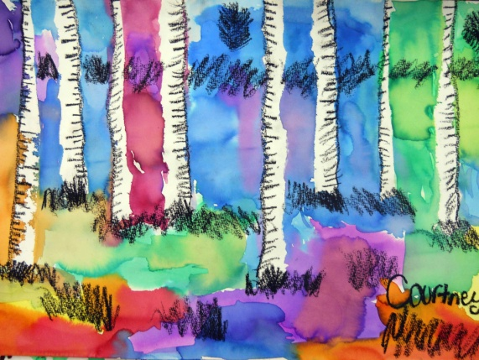

Colorful Forest
Medium: Mixed Media Watercolor and Oil Pastel

Formal Description of Dyslexia
Dyslexia is a learning disability that makes it harder to read. Typically, the person fails to see words in the order displayed on the pages. His or her mind plays a trick on the learner, sometimes reversing letters, sometimes scrambling them. Often children with this challenge are slow to learn to speak and have to work very hard to learn what their brain is seeing on the page and then to interpret it in a way that others can also understand what the chi means. (Office of Communications and Public Liaison, N. I. O. N. D. A. S., 2011 p. 1) The effects of dyslexia can be minimized with hard work. It is critical that this child not feel like a failure or not smart enough in any way. Most often she or he is of average or above average intelligence, she or he just has this mind trick converting what is seen or heard by the brain into information that the average person can understand.
The Artist’s Perspective of the Picture
The colors in the picture show my moods and how I am feeling. I chose bright colors for the forest because it makes it more of a beautiful day than a cloudy day. In addition, the colors I chose are my favorite colors. When creating my piece, I used tape by ripping pieces apart to make the lines for the trees. I want others to see the beautiful colorful forest and have a good mood too. Having a challenge like dyslexia makes my work hard at school. I would like other children to know that having dyslexia makes it difficult for me to write and express myself and hard to learn too.

Questions to ask your kids?
- What can you see in this picture that seems to reflect seeing things backward?
- Do you think you are seeing this picture the way the artist does?

Deaf
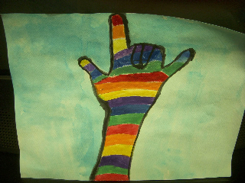

I love you! That’s Our Sign Language!

Medium: Water Color

Formal Description of Deaf
Deafness is a hearing impairment. Some people who are deaf prefer the term “deaf” and some prefer the word “hearing impaired”. The artist represented in the exhibit prefers deaf. According to Hamil and Stein, traditionally, deafness is conceptualized as a medical problem or disability. However, many Deaf people these days identify themselves as ethno-linguistic minority that takes pride in being Deaf (Hamil & Stein, 2011). Deaf children with hearing parents tend to face a lot of challenges especially when the parents do not sign and communication becomes a barrier. Deaf children tend to have more behavioral problem in this kind of environment due to communication barrier between them and their parents (Stevenson, McCann, Watkin, Worsfold & Kennedy, 2010). They do like to communicate and express their feelings with the people around them. Therefore, many Deaf people like to express their feelings using art.
The artist’s perspective
I Love the rainbow. My favorite thing on this art is “I love you hand.” I love the colors; purple, red, green, white, blues and I want more and more colors. I love looking at the rainbow above the ocean. This “I love you” means to my parents, my sisters and brothers, my family. This is very easy sign that everyone can learn. I want children of my age who can hear to learn this sign. I want to make friends with them too and want them to teach them how to sign, so that I can make friends with them. I love drawing using many colors. I also love to draw animals with different color combination. I want to become famous artist. When I grew up I am dreaming to do art exhibition around the world and many people will come to look at my art.

Questions for Parents
- How do you express your feeling any other than speaking out loud?
- How do you see yourself in this artwork?
- What was the artist thinking when he created the art?

Seizure Disorder
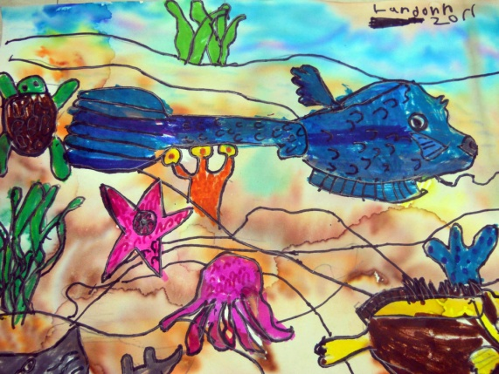

Under The Sea
Medium: Marker
Formal Description
Depending on the type of Seizure, a child who has a Seizure disorder has a history of seizure events. The child experiences, “a convulsion or other clinically detectable event caused by a sudden discharge of electrical activity in the brain.” (Unknown 2005, P. 1966) There are a variety of different types of seizure; parents should ask the impacted child’s parents what they need to know should their child have such an event. Depending on the age of your own child, you may want to talk with them about it as well. Your child has nothing to fear by being with a child with this challenge. Many children who have seizures have no memory of the event, they simply stop playing or walking and seem to be very distant for a matter of 30 or 40 seconds. Some children will fall to the ground and experience involuntary movements. It is important that other children are not afraid to be with persons with a seizure disorder and to not treat the person as if there is something strange about them.

Artist’s Perspective
“I like to create. I like the ocean. The day was sunny and a good day. I felt good on the day I made my art work. I wanted the ocean to be nice and beautiful.”

Questions for Parents
- Do you like this picture? What do you see?
- What do you think you would feel if you saw a friend have a seizure?
- Do you know what they will need to keep them safe if they have a seizure?

Asperger’s Disorder

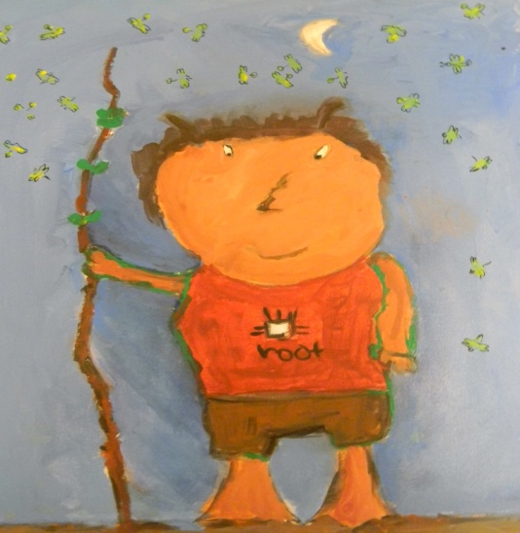

Root Boy
Medium: Charcoal and Paint

Formal Description
Persons who have Asperger’s Disorder reflect “severe and sustained impairment in social interaction and the development of restricted, repetitive patterns of behavior, interests, and activities?” (APA (2000) p. 80). Frequently persons with Asperger’s Disorder have impaired eye to eye contact, facial movements or body postures. (APA (2000) p. 80) This disorder can be paired with other disorders but when seen by itself, many of the behaviors exhibited will seem different or strange to other children. Parents will need to talk about with their children about this and help them to find good things about the person to alter the focus from the challenges. Children should also be informed that they have not done anything to prompt these behaviors.
Artist’s Perspective of “Root Boy”
I painted this picture when I was 7 years old. I painted this picture because my art class was learning about Mother Earth. I think the earth is pretty. “Root boy” looks cool like a cartoon. I see his face when I look at him. He looks like a tree. I like nature and trees. When I painted “Root boy” it reminded me not to litter. We need to take care of the earth. I like to play with Legos and play video games but my favorite thing to do is to draw. I am good at drawing. I like to draw with my friends. Other people tell me my drawings are “awesome” and “will you draw me one?” This makes me happy and proud.

Questions for Parents
- How do you think a person with this challenge feels about you and the other kids?
- Do you think they do these things intentionally?
- What do you like about this person?

Attention Deficit Hyper Activity Disorder
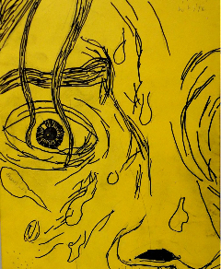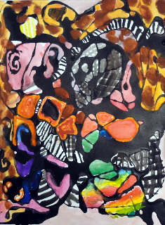
Imagination is Sweaty Work Movement, Movement, Movement
Medium: Colored Paper and Ink Medium: Paint and Ink on Paper

Formal Description
According to the Diagnostic and Statistical Manual of Mental Disorders (4th ed., text revision, American Psychiatric Association, 2000), Attention-Deficit/Hyperactivity Disorder (ADHD) is a chronic health condition that displays a frequent or consistent pattern of inattention and/or hyperactivity-impulsivity. It is commonly prevalent among school-aged children. Some of the symptoms seen in individuals with the hyperactive-impulsive type include frequent fidgeting or squirming in seat, excessive running or climbing about when inappropriate, difficulty playing and engaging in leisure activities quietly, difficulty waiting turn and often interrupts or intrudes on others. Individuals with the inattentive type may often have difficulty organizing tasks and activities, easily distracted, has difficulty keeping attentive in tasks or play activities. There must be clear evidence of disruption in social, academic and/or occupational functioning.
The artist’s perspective of “Imagination is Sweaty Work”
I am 16 years old and I drew this picture a little over a year ago. It was an artwork project from school. It is the cover for my artwork in the classroom. It shows me concentrating on creating the artwork. I started with pencil and I wanted it to look like a comic book detail. I just like the sweat running down the face, as it was how I felt drawing it. Being creative is hard work. It describes me because I am unpredictable. I enjoy people looking at my picture and I want them to like me. Can you see the sweat in the picture? What kinds of things are challenging work for you?
The artist’s perspective of “Movement, Movement, Movement”
My favorite part is the rainbow looking area I liked how it blended together and then changed and changed and changed. I made different animal prints in there, zebra giraffe, and leopard prints; I thought I would bring in animals….why animals? Not sure, it looks pretty cool.
It’s unpredictable, I’m very random. I think faster than everybody else and I need to slow down. I’m scattered my thoughts are usually scattered, when I draw I can calm down, when I’m drawing everyone will tell you I’m unable to stay concentrated but when I’m drawing or reading, I stay concentrated not even a blink.
When I’m drawing I feel calm, I feel like I’m putting my energy on the paper, my thoughts and everything” I want them to see me, the way that I feel, the way that I am, a lot of times I get written of and they say he’s just a weirdo. I hope they understand that I’m weird but I’m the good kind of weird, I am me.
Questions for Parents
- Can you see the zoo animals in the colorful picture?
- What do you think the artist was thinking about when he created this art?
- Does your brain work so fast sometimes that it feels like hard work?

Down’s Syndrome
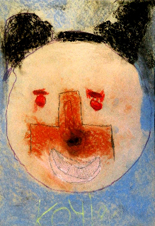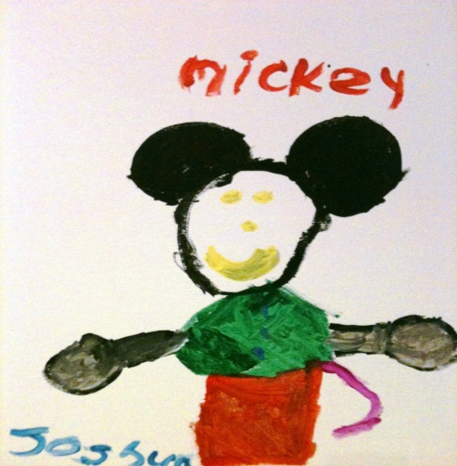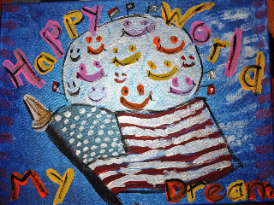
It’s Me! Mickey Mouse! Happy World, My Dream
Medium: Pastel Chalk Medium: Acrylic on Canvas Medium: Acrylic

Formal Description

Down’s syndrome is a genetically based challenge (this means people are born with it). Persons with Down’s syndrome struggle with both physical characteristics as well as mild to moderate retardation. Physically, the individual may have a “sloping forehead, low-set ears” (Unknown, 2005. P. 631) they may also have a flat looking nose and somewhat slanted eyes. Children often notice the physical characteristics first. However, behaviorally, persons with this challenge are often very friendly and willing to share with others. In school, a person with Down’s syndrome often needs to work harder than other children but they can and will learn what they are being taught. Just like children without Down’s syndrome, children with it have different levels of ability and functionality.

There are 3 pictures in this exhibit by artists who have Down syndrome.

The artist’s perspective for “It’s Me!”
This is my picture. I am 13 years old. I drew this picture a year ago, and now I want to tell you a little bit about the picture that I drew. This is a picture of me. When I was in Art class a while ago, my teacher asked me to draw a picture of my face; while looking in the mirror. She told me that I could use chalk to draw my picture. I love drawing with chalk; I really enjoy drawing pictures on the sidewalk. When I started to draw my face, I got chalk ALL over my face! It was so funny, and I laughed. I like to laugh, and I like to smile. Can you see me smiling in my picture? I was really happy when I drew this picture. I drew hair in my picture too; it looks just like my hair. I really like to look at my picture, and it is hanging in my house. In my picture, I have eyebrows and I’m happy. You see, I’m just like all the other kids my age. I like to draw, I go to school, I like going to the park, and I like going to the mall. When other people look at this picture, I want them to see my eyes, my nose, and my hair. When kids look at this picture, they should point to my eyes, my nose, and my hair. Can they find them in the picture? I chose blue for the background because it is my favorite color. When my mommy looks at this picture, she says I have nice hair. I want people that learn about me to know that I am a happy person and I like to laugh. I also like the movie, “Twilight”; and want to go see it with my friends. I really hope that you enjoyed looking at my picture, and hope that you remember that people like me enjoy making new friends and playing. I like drawing most of all.

The artist’s perspective for “Mickey Mouse”

I go to the children's art museum in my town every week that is where I painted this picture. I painted Mickey Mouse because he makes me happy. I want you to know that I am happy person and I like to do fun things. I like going to the movies, watch plays, and have play with my cousins, and I take guitar lessons.

The artist’s perspective for “Happy World, My Dream”
This is a picture of a flag. I included the smiley faces because I like them. The way I see my world is happy….just happy. The people in my world are my brother, Will, mom, dad, my aunt Lala and two friends from school. It took me two art class periods to complete this piece of art. I like to watch Scooby Doo. The thing I want others to know about me is that I am happy. What do you feel when you see this picture? Who are the people in your “world”?

A Few Questions Parents Can Ask
- What do you like about these pictures?
- Who do you think drew this picture? Do you think they are someone like you?
- Do you know anyone in your class that looks different than the rest of the class?
- Do you know anyone in your class that acts differently than the rest of your class?

Autism

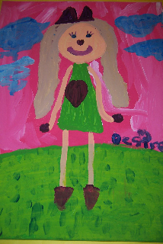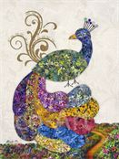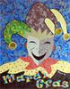
Beautiful Girl The Peacock at the Zoo Jester of Mardi Gras
Medium: Acrylic on Canvas Medium: Puzzle pieces Medium: Recyclable Material

Formal Description
Autism is a pervasive developmental disorder which can cause problems with thinking, ability to communicate, or ability to play with others. Sometimes children that have Autism are very gifted at other things such as music. Each individual is unique, the symptoms of Autism varies in its severity and may include such characteristics as: increased sensitivity in smell, sight, hearing, taste or touch. (Autism Speaks, 2013)
The artist’s perspective for “Beautiful Girl”
I am a 9 year old girl. I like my art. This is a picture I drew at Halloween. I dressed up like a cat and my brother dressed up like a paper boy. It was kind of rainy that day. Can you tell that this is a picture of me? I’m beautiful! I hope you can see that. I’m smart. I get mostly A’s even though there are some things I have trouble doing. I’m also very creative. Can you see the smudges on my face in the photo? I want people that look at my art to know that they shouldn’t call people names that are different from them. People should be nice. I enjoyed making my art.

The artist’s perspective for “The Peacock at the Zoo”
I was inspired to produce this peacock after a visit at the local zoo. My artwork was created using ecofriendly materials like 4,000 puzzle pieces, beads, wallpaper, and hairpins. I am extremely detailed so to the point that I use the design from the top layer of the puzzle pieces by peeling it from the rest of the piece. The lane the peacock travels down to get home is a flat puzzle board. I remember my mother telling me about a street she lived near when she was younger called, “Peacock Lane.” I love art and doing artwork relieves anxiety, feels like meditation, feels good, and keeps me busy. Have you found the hairpins yet? Look at the peacock’s feet. The message I want others to know about Autism when they see my art is that it is important for parents to tell their children they have it because it can make their life easier. Life can get challenging, but once they know they can be set free. It is not a bad thing but I experience it my repetitive behaviors as a gift. My disability is my ability to change the world.
The artist’s perspective for “Chester Clown”
This art piece is based on the thespian masks, and is part of a series based on a Mardi Gras theme. The artist who created this art piece has a diagnosis of Asperger’s Syndrome, which is a form of autism. He felt that the thespian masks represent the faces of Autism. The artist is an “eco-artist” and used paper from wallpaper books to create this collage. He said that creating his art is a form of meditation for him. The artist says, ‘It’s not what we can’t do… It’s what we can do!’

Questions for parents to ask their children:
- Two of these pictures are made up of hundreds of tiny pieces of shinny paper, put together like a puzzle. Do you think you would have the patience to do that?
- What do you see when you look at these pictures?
- Do you think children with Autism enjoy some of the same things that you enjoy? If so, what?

Bibliography
American Psychiatric Association. (2000). Diagnostic and statistical manual of mental disorders
(4th ed., text rev.). Washington, DC: American Psychiatric Association.

Autism Speaks (2013, February 12). Retrieved from http://www.autismspeaks.org/what-autism

Hamill, A. H., Stein, C. (2011). Culture and empowerment in the Deaf community: An analysis of internet weblogs. Journal Of Community & Applied Social Psychology, 21(5), 388-406.

Kaneshiro, N. (2010). Retrieved from A.D.A.M Medical Encyclopedia website: http://www.ncbi.nlm.nih.gov/pubmedhealth/PMH0001992/

Office of Communications and Public Liaison, N. I. O. N. D. A. S. (2011). Ninds Dyslexia
Information Page, U.S. National Institutes of Health.

Silverman, L. H. (2010). The social work of museums. Philadelphia, Routledge Press.

Simon, N. (2010). The participatory museum. New York, Museum.

Stevenson, J., McCann, D., Watkin, P., Worsfold, S., & Kennedy, C. (2010). The relationship between language development and behavior problems in children with hearing loss. Journal of Child Psychology & Psychiatry, 51(1), 77-83.

Talking to kids about mental illness. (2011, March). Retrieved from http://www.aacap.org/cs/root/facts_for_families/talking_to_kids_about_mental_illnesses

Unkown (2005). Seizure. Taber's cyclopedic medical dictionary. D. Venes. Philadelphia, F. A. Davis Company.

What is down syndrome?. (2011, February 23). Retrieved from http://www.nichd.nih.gov/health/topics/down_syndrome.cfm

Wilkening, S. (2009). Life stages of the museum visitor: Building engagement over a lifetime.
New York, American Association of Museums.

Booklet created by:
The Baylor School of Social Work faculty participants: Dr. Jim Ellor, Ms. Becky Bell Scott. Student participants: Michelle Acas, Diona Cortez, Julie Coston, Katreva DuPont, Kay Dunlap, Melissa Erb, Aide Felix, Celia Feller, Crystal Graham, Jasmine McGregor, Sheena Moore, Sasha Roskos, Anthony Stewart, Biak Sung.

