Baylor University
Presents

A Lifetime of Knowledge!

Summer European Business Seminars
May 22, 2009 to June 14, 2009

Visit World Famous Companies such as:

BMW Dingolfing
Munich Messe (Main Trade Fair)
Riedel Glas in Kufstein
Innsbruck Tourist Board
GE Nuovo Pignone
Swarovski Crystal Worlds
Parfumerie Fragonard
Fidelity Investments
OECD
Bank of England
Lloyd’s of London

Stay at Four-Star Hotels in:
Munich, Germany
Innsbruck, Austria
Florence, Italy
Nice, Avignon, and Paris, France
London, United Kingdom

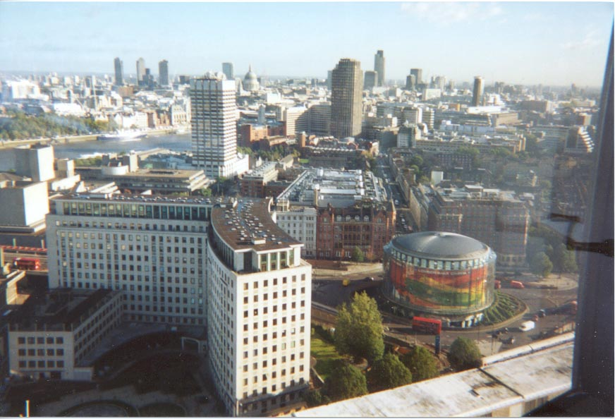

Enjoy the Culture and History of Europe:

Visit the Dachau Memorial Site
Tyrolean Lantern Hike & Mountain Viewing
Tours in most Cities
See the Leaning Tower of Pisa
Visit Monaco/Monte Carlo & the Royal Palace
Listen to a French/American Cultural speaker
Learn about Current Issues in the EU

Baylor European Business Seminars is an opportunity of a lifetime! Students participate in a variety of activities including lecture-discussion sessions and factory tours with executives of various multinational corporations, local business firms, and government agencies. Participants investigate business policy, strategy and structure in an international context while emphasizing the marketing and management functions of seminar hosts. The overall purpose of the Seminars is to allow participants to be exposed to international business practices outside the United States. Additionally, participants gain insight into the cultural, social and political environments of each country visited.

Students can earn up to six hours of credit with the following courses:

BUS 3310 or MKT 4324 and/or MKT 4325 or MKT 4398.
Courses may be applied to the degree plan for the student’s major or as a business elective. Non-business majors may find an application for one or more of these courses in their degree plan.

Price starting at $5,709.00
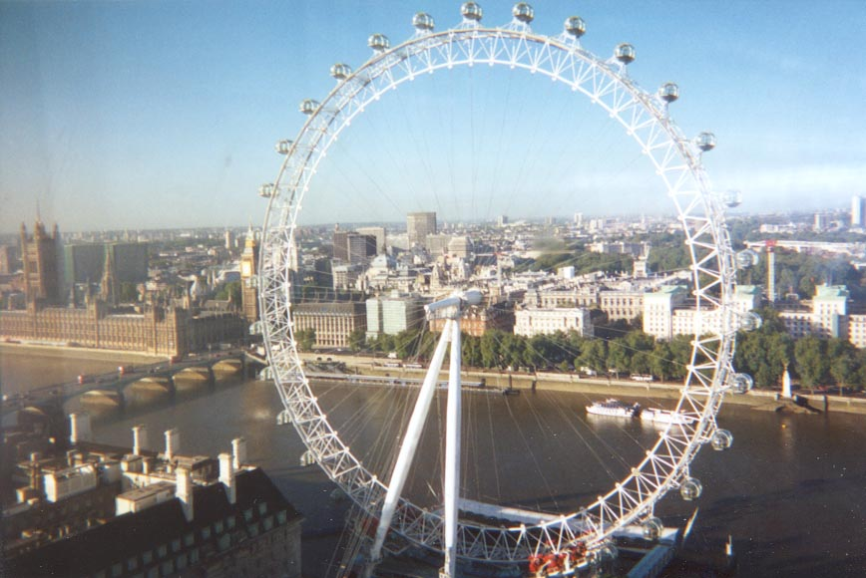
For additional information contact:

Roger Davis, M.B.A.
Department of Marketing (HSB 224)
Hankamer School of Business
Baylor University, Waco, TX
Tel: (254) 710-4303
Included in the Seminar Price of $5,709.00
*Seminar program as detailed in the itinerary.
*Twin bedded hotel accommodations with private facilities in centrally located four star hotels.
*Continental breakfast daily.
*Sightseeing and excursions as outlined in the Seminar program.
*Surface transportation overseas aboard deluxe private motorcoach.
*Escorted by qualified university professors.
*Business content of the Seminar visits.
*Academic Travel and Readings Books to help participants prepare for the Seminar visits, coursework and examination.


Not Included in the Seminar Price of $5,709.00
*International Airfare from the United States.
*Airport transfers to and from the hotels in Europe.
*Tuition for up to six credit hours (two course equivalency).
*Passport and visa fees.
*Any required immunization.
*Porterage at airports and hotels.
*Overweight baggage costs.
*Most lunches and dinners.
*Free time activities and optional excursions.
*Public transportation overseas unless part of the formal Seminar program.
*Replacement of passport and other lost items and expenses incurred in their replacement
*Medical expenses arising from illness, including transportation to rejoin the Seminar group, and any extra expenses associated with the illness.
*Travel and accident insurance.
*Reimbursement for overnight lodgings, meals, transportation, or missed travel services due to airline scheduling, misconnections or delays.
*Voluntary supplemental tip to the Coach driver.

International Airfare Package
*International Airfare from United States gateway city of Dallas or Houston (round-trip non-refundable non-changeable tickets).
*Luggage tags and 50 pounds of luggage allowance (maximum 1 piece, not to exceed 62” (L+W+H)).
*Airport transfers to and from the hotel in Europe.
* The price of airfare is guaranteed if paid in full by February, 15, 2009, at $1,285.00 from Dallas and $1,193.00 from Houston.
*Once final payment is received, nonrefundable tickets will be issued that cannot be changed or cancelled for refund.
*If you are considering making your own flight arrangement you must contact IBS to get the group’s flight itinerary as you will be responsible for meeting the group in Europe. No airport transfers to and from the hotel are included if you make your own flight arrangements.

Registration Procedures and Payment Plan
Timely payments are necessary so that the International Business Seminars can meet financial obligations overseas. Bankcards and major credit cards cannot be accepted.

- Read the material carefully.
- Complete and sign the application forms.
- Make a copy of your application forms for your own information.
- For the Seminar: A $400.00 deposit made out to Baylor University. Final payment for the seminar will be due by March 15, 2009 and should be paid to Baylor University.
- For the Airfare: A $100.00 deposit made out to International Business Seminars. Final payment for the airfare will be due by February 15, 2009 and should be paid to International Business Seminars.
- Give the completed and signed application forms, with both deposits, to Prof. Roger Davis, Dept. of Marketing, Hankamer School of Business, Baylor University. (Applications that are not complete or are not signed by the participant may be returned for completion).
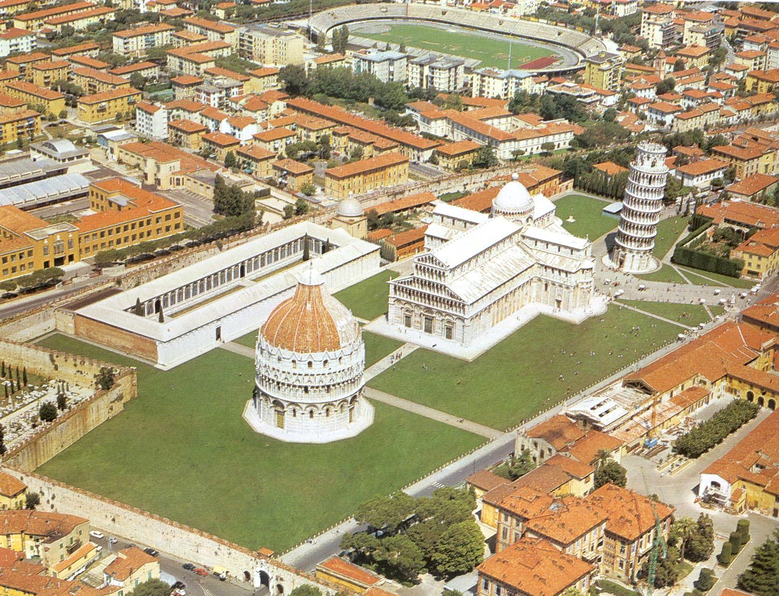

BAYLOR UNIVERSITY
EUROPEAN BUSINESS SEMINAR ITINERARY

May 22, 2009 to June 14, 2009
Munich, Germany; Innsbruck, Austria; Florence, Italy;
Nice, Avignon and Paris, France; and London, United Kingdom

DAY/DATE | ACTIVITY | LODGING
Friday, May 22 | Depart USA | Airplane
Saturday, May 23 | Arrive Munich and Transfer to Hotel | Munich
Sunday, May 24 | 9:00 AM: Orientation Session  2:00 PM: Tour of the city to include the Dachau Memorial Site | Munich
Monday, May 25 | 10:00 AM: BMW Dingolfing Assembly Plant  2:30 PM: Munich Messe (Main Fair Organization) | Munich
Tuesday, May 26 | Free to enjoy Munich | Munich
Wednesday, May 27 | AM: Travel from Munich to Innsbruck  10:00 AM: Riedel Glas in Kufstein  3:00 PM: Innsbruck Tourist Board  5:00 PM: Mid-seminar Discussion Session | Innsbruck
Thursday, May 28 | 10:00 AM: Swarovski Crystal  Afternoon: Free for activities  7:30 PM: Tyrolean evening - Lantern Hike & Mountain Viewing | Innsbruck
Friday, May 29 | Free Day in Innsbruck/Cultural Immersion | Innsbruck
Saturday, May 30 | AM: Travel from Innsbruck to Florence | Florence
Sunday, May 31 | 9:00 AM: Walking tour of the city  Free Time in Florence/Cultural Immersion | Florence
Monday, June 1 | 9:30 AM: GE Nuovo Pignone  2:30 PM: US Consulate or Chianti winery | Florence
Tuesday, June 2 | AM: Travel from Florence to Nice  Enroute Short stopover in the city of Pisa  PM: Arrive in Nice and transfer to Hotel | Nice
Wednesday, June 3 | Free to enjoy the French Riviera/Cultural Immersion | Nice
Thursday, June 4 | 10:00 AM: Texas Instruments  2:30 PM: Parfumerie Fragonard  PM: Visit Monaco/Monte Carlo | Nice
Friday, June 5 | AM: Travel from Nice to Avignon  Enroute Visit Pont du Gard | Avignon
Saturday, June 6 | AM: Travel from Avignon to Paris  PM: Arrival Paris and transfer to the hotel | Paris
Sunday, June 7 | 9:30 AM: City Tour of Paris | Paris
Monday, June 8 | 10:00 AM: Fidelity Investments  2:00 PM: French/American Cultural w/Shari Segall | Paris
Tuesday, June 9 | 10:00 AM: OECD  Afternoon: Cruise on the Seine River | Paris
Wednesday, June 10 | AM: Travel from Paris to London by Eurostar Train  PM: Arrival in London/Immediate city tour/ Transfer to Hotel | London
Thursday, June 11 | 10:00 AM: Bank of England (Split visits)  10:30 AM: Lloyd’s Of London Insurance Market (Split visits) | London
Friday, June 12 | 9:00 AM: Current Issues in the European Union with  Tom Lawton/Imperial College at Hamilton House  11:00 AM: Wrap up/Discussion and Exam at Hamilton House | London
Saturday, June 13 | Free day to enjoy the city | London
Sunday, June 14 | Return to USA or Begin Independent Travel

Seminar Ground Only Price $5,709.00 (includes four-star hotels with breakfast, ground transportation, & reading materials. Does not include cost of airfare, tuition, most lunches and dinners, and free time excursions.)

International Airfare Package (includes guaranteed airfare if paid for by February 15, 2009: $1,285.00 from Dallas, $1,193.00 from Houston, and airport transfers to and from the hotel in Europe. If you are considering making your own flight arrangement you must contact IBS to get the group’s flight itinerary as you will be responsible for meeting the group in Europe. No airport transfers to and from the European hotels are included if you make your own flight arrangements.)

We make every effort to maintain the above itinerary and though it is not done frequently, it is subject to change.

Past Participants Have Told Us:

“…The European Business Seminars was the best financial investment I made in my career.”

“…I will always remember and appreciate the Baylor European Business Seminars because it gave me a sense of my own past and a sense of the future of business in the world.”
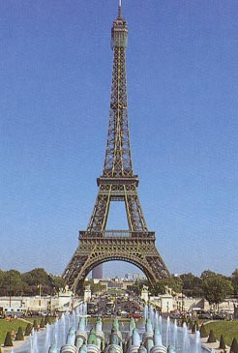
“I probably learned more in three and a half weeks in Europe than I will in one year at Waco.”

“…The trip gives you an intense understanding of the differences in cultures and gives you the point of view of someone who can look back at the U.S. and fully appreciate our advantages and get insight into the areas in which we need improvement.”

“…The European Business Seminars trip will aid in selecting a career path as well as understanding foreign trade.”

“…I highly recommend the European Business Seminars to anyone interested in international or intercultural business issues.”

“…this was like stepping through the keyhole in a door. It was even better than I hoped…and my expectations were high!”

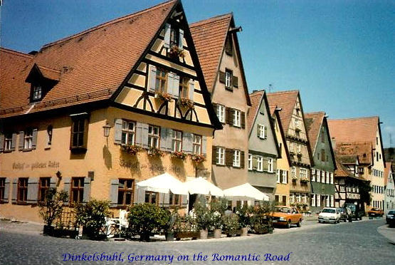
“…I had no idea how it would open my eyes and let me see the world in a new light.”

“…The benefit to the student is not just an academic exercise. The benefit of the course is the firsthand experience of history, culture, societies and relating to people in the international business arena.”

“…The official visits were well planned with an interesting variety of businesses and governmental sites. The speakers were well informed and were genuinely interested in us as students.

“…I truly keep wonderful memories of the European Business Seminars program not only because I experienced Europe for the first time but the entire set of friends, professors, program activities surrounding the business visits, gave a true picture of the EU. I never would have received such experience without your program.”

FOR MORE INFORMATION CONTACT:

Roger Davis, M.B.A.  Senior Lecturer in Marketing  Department of Marketing  Office: Graduate Offices, Room 240  Hankamer School of Business  Baylor University  P.O. Box 98013  Waco, TX 76798-98013  Tel: (254) 710-4303  Email: Roger_Davis@baylor.edu | Home Office:  International Business Seminars  P. O. Box 1823  Scottsdale, AZ 85252-1823  Tel: (480) 874-0100  Email: info@ibstours.com  Website: http://www.ibstours.com

