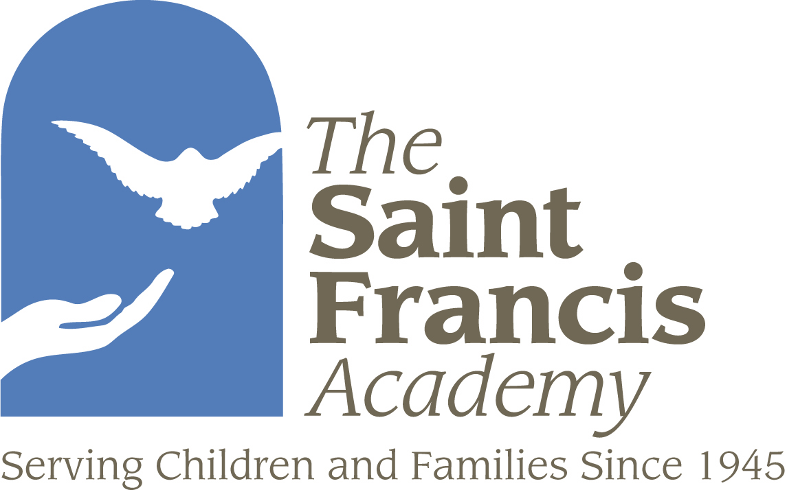

LBSW/LMSW/LCP/LMFT

Social Worker, Reintegreation: (Requires LBSW)

Liberal, Dodge City, Garden City, Wellington, Hutchinson, Hays & Great Bend.

Therapist, In Home Family Therapy
(Requires LMSW, LMFT, LCP)

Great Bend/Hays, Hutchinson/ Newton/Wellington, Dodge City/Garden City/Liberal

Therapist, Family Preservation:
(Requires LMSW, LMFT, LCP)

Dodge City Liberal, Hutchinson & Hays.

For more information please contact:

Norma Offutt
HR Manager
501 N Monroe
Hutchinson, KS 67502
620-669-3734 X 152
785-787-2501 Cell
620-669-0572 Fax
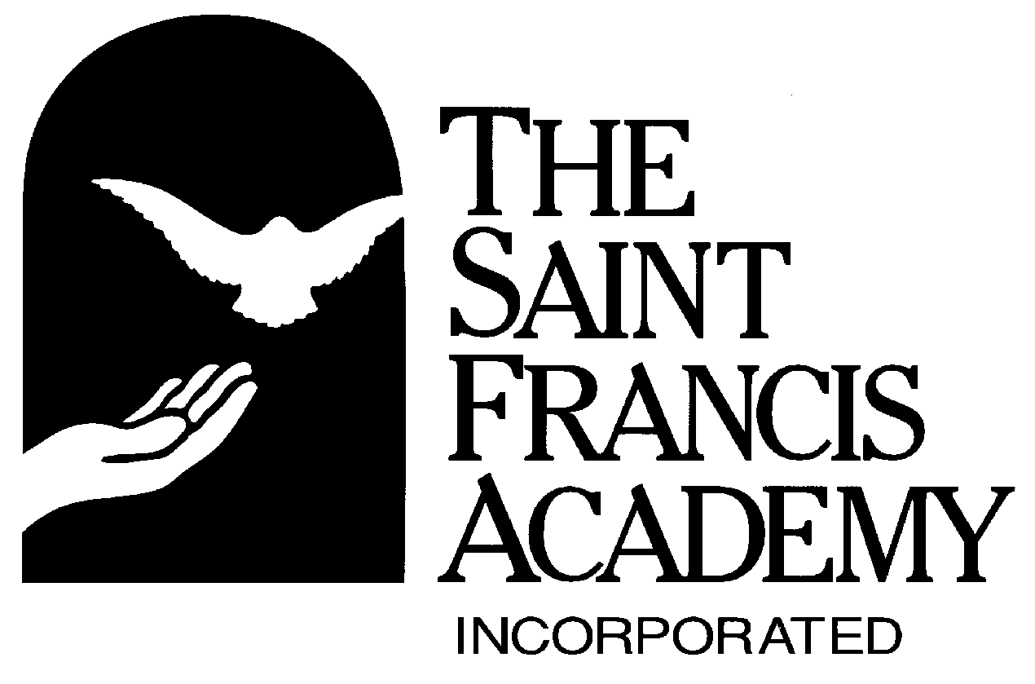


St. Francis Academy Benefit Overview

2007 SUMMARY OF EMPLOYEE BENEFITS

MEDICAL
- Dual Option Medical Plan. Choose the plan that fits your family needs. Choose from either a $1,000 per person deductible or a $2,000 per person deductible.
- Office Visit Co-Pay will be $20

Election | 2007 $1,000 Ded | 2007 $2,000 Ded
Employee only | $7.50/paycheck | $0.00/paycheck
Employee + 1 | $82.50/paycheck | $75.00/paycheck
Family | $207.50/paycheck | $200.00/paycheck

PRESCRIPTION DRUG
- $10 Generic , < 50% or $50 Brand Name
Benefit Maximum is $10,000
- You must enroll in one of the medical plan options to be eligible for the pharmacy plan.

Election | Pharmacy
Employee only | $5.00/per paycheck
Employee + 1 | $45.00/per paycheck
Family | $70.00/per paycheck

DENTAL
- Dental Benefits are 100% for preventive, 80% for basic and 50% for major services after a $50 per person ($150 per family) deductible. These benefits have a $1,500 per calendar year maximum.
Election | 2007 Plan Year
Employee only | $2.50/paycheck
Employee + 1 | $10.00/paycheck
Family | $24.00/paycheck

The employee benefits will be effective the first of the month following 30 days of employment.

LIFE INSURANCE
- Life Insurance and Accidental Death and Dismemberment coverage is provided and paid for by St. Francis Academy. This policy is based on your annual salary to a maximum of $250,000. Life & AD&D coverage is effective first of the month following six months of employment.

SHORT-TERM DISABILITY COVERAGE
- STD coverage is provided and paid for by St. Francis Academy. This coverage begins on the 15th day for accident or illness and continues for 24 weeks. The maximum benefit is $500 per week. STD coverage is effective first of the month following one year of employment.
LONG TERM DISABILITY COVERAGE
- Long Term Disability Coverage on a voluntary basis through Advance Life Insurance. This policy will allow you to have coverage in the event that you are off work for 180 days. The benefit is 50% of your earnings and will be in effect for 2 years. The premiums will be taken through payroll deduction. LTD coverage is effective first of the month following one year of employment.

FLEXIBLE SPENDING PLAN
- This benefit allows you to pay for your out-of-pocket medical, dental and vision expenses and dependent care expenses with pre-tax dollars, which lowers your tax liability.
- All claim forms are processed through Human Resources in Salina.
- All reimbursements are added to your next payroll check.

Pension Plan (403B)
  - SFA will contribute 5% of the employee’s annual gross pay to the Pension Plan without any contributions by the employee. If the employee elects to contribute to the Pension Plan, SFA will match an additional amount up to 5% of the employee’s contribution. That’s a total of 10% contribution by SFA. Employees are vested at 100% from the day they begin the plan. Employees are eligible for the Pension Plan first of the month following one year of employment, 1,000 hours of service, and attainment of age 21.

Holidays
  - St. Francis Academy observes 10 ½ paid holidays per year for full-time employees.

Sick Leave
  - An employee earns 8 hours of sick leave each month. Employees are eligible to utilize sick leave after completing 6 months of continuous employment.

Vacation Leave
  - SFA has established a vacation/annual leave policy to provide you an opportunity to have paid time away from your job responsibilities. Employees are eligible to utilize this benefit after 6 months of continuous employment.

Paid Leaves
  - The purpose of our paid leave program is to provide income protection to employees. Full-time employees that have completed six months of employment are eligible for these paid leaves: Bereavement, Jury Duty, Conference or seminar (continuing education) leave, along with sick leave, stated above.

Unpaid Leave
  - SFA also has unpaid leaves with the appropriate documentations. They include: FMLA Leave, Medical/Disability Leave, Military Leave, Personal Leave.

Questions about benefits may be directed to Cammie Cooper, HR Comp & Benefit Manager in the Salina Office at 1-800-423-1342 extension 137 or email cammie.cooper@st-francis.org.

