News Corp in Crisis

Baylor University National Case Competition in Ethical Leadership

November 2011

Case Developed by

Dr. Mitchell J. Neubert

Shannon Evans

Baylor University

Hankamer School of Business

Waco, Texas

For permission to use this case for instructional purposes, please contact the lead author at Mitchell_Neubert@baylor.edu or 254-710-4092
News Corp in Crisis
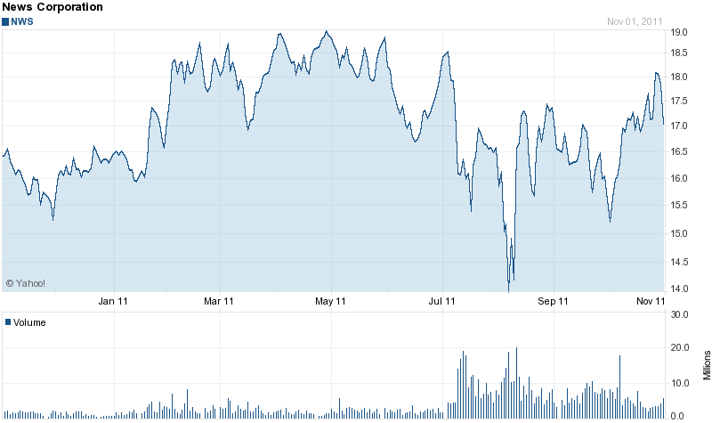
Overview
News Corp is the one of the world’s largest media conglomerates, second only to The Walt Disney Corporation in terms of revenue. It has vast and diverse media holdings that include News Limited, 20th Century Fox, Fox Broadcasting Company, HarperCollins Publishers, News International, and the Dow Jones & Company and its subsidiary, The Wall Street Journal.

News Corp has faced many challenges in the past year. Many would say this is because of their own deliberate actions and, in some cases, their inaction in cases of significant ethical and legal issues that have been discovered. Publicly, the company has been affected in the short run, with stock prices plummeting because of their most significant case of alleged unethical and illegal behavior involving one of their British publications, News of the World. Remarkably, the company’s stock price has rebounded and is trending up towards yearly highs. Even as stock prices have rebounded, however, leadership has been called into question. It remains to be seen how long their reputation can withstand negative news as additional cases of unethical and illegal behavior surface and the News of the World case is concluded.

News of the World
In January of 2011, British police opened a new investigation into the hacking scandal that was previously alleged but not pursued in 2009 as new allegations emerged. Over 63 claims were filed as of October: the list included “movie stars, politicians and parents of two child victims of horrific violent crimes.” There has been recent evidence that suggests that knowledge of phone hacking was widespread, as early as 2008, and was even known by James Murdoch, the CEO of the paper at the time. There have been at least two financial settlements so far. One settlement was estimated at around £60000, for Kelly Hoppen, an interior designer whose messages were intercepted. The case is ongoing. The family of Milly Dowler, a young girl who was murdered, received £2 million as a settlement for a civil suit and Rupert Murdoch has agreed to a £1 million donation to charity. The company has acknowledged that hacking did take place at the paper. The scandal resulted in the closure of the 168-year-old paper, but legal issues continue to develop. As investigations continue, News Corp will have to deal with the consequences for the foreseeable future.

Competitive Intelligence or Espionage
Perhaps fueled by the phone hacking scandal, in late July US Justice Department prosecutors decided to take a second look at allegations involving a News Corp division, News America Marketing, stealing information from a competitor. The case involved the hacking of Floorgraphics computers to gain competitive information. The dispute was settled in 2009, just weeks into the trial, when an agreement was reached in an out-of-court settlement for News Corp to purchase Floorgraphic’s assets for $29.5 million.

Wall Street Journal Europe
“Andrew Langhoff, managing director of Dow Jones in Europe, Africa, and the Middle East, and publisher of The Wall Street Journal Europe stepped down.” There have been suggestions that the company funneled money to European companies to then purchase copies of its own papers to enhance the appearance of circulation numbers, misleading advertisers and readers. Additionally, senior management of Dow Jones, the parent company that News Corp bought in 2007 and the parent company of the Wall Street Journal, did not react to the scandal in a significant way when they found out about it last year. A whistleblower named Gert Van Mol came forward and they are now taking immediate action to address the issue. They have not admitted any wrongdoing so far, but did release the statement that, “we were uncomfortable with the appearance of these programs and the manner in which they were arranged. We subsequently eliminated the position of one of the employees [Gert Van Mol] responsible for those deals in January 2011.”

What Goes Around Comes Around
In an ironic reversal of events, the Lulz Security hacking group announced in July that it had hacked into News Corp information systems. In addition to redirecting visitors to a site that declared the death of Rupert Murdoch, the hackers were successful in gaining access to personal emails and voicemail accounts, and in disrupting Internet traffic to several News Corp websites. Among the several News Corp entities targeted was British newspaper The Sun; hackers claim to have posted the name and password of The Sun’s network administrator. It is not known if the hackers were also able to gain access to subscriber’s personal information but it is clear that News Corp has its own information security concerns to deal with to protect the privacy of its customers and the integrity of its information systems and Internet sites.

Recent Acquisitions
Despite its failed acquisition of British Sky Broadcasting due to backlash of the phone-hacking scandal, News Corp announced this November that it has secured a deal to acquire Christian book publisher Thomas Nelson through its subsidiary HarperCollins. An acquisition is not surprising given that News Corp chief operating officer Chase Carey signaled an interest in using their excess cash for acquisitions that would build their current business. This acquisition brings under one umbrella Thomas Nelson and Zondervan, the two largest Christian book publishers.

Not everyone is likely to be happy about the new relationship. During the height of publicity regarding the phone-hacking scandal, some Zondervan authors went public in questioning how the publisher of Bibles and religious books could commit such an egregious ethics violation. Also, given many analysts expected News Corp to use its cash to acquire digital assets, such as last year’s acquisition of Wireless Generation, the announcement raised some eyebrows. From another perspective, religious books may be a safe bet. In a declining industry, sales of religious books are up slightly. Brian Murray, HarperCollins chief executive, had this to say about the acquisition, “Thomas Nelson adds further balance to our existing publishing programmes. Its broad inspirational appeal is a good complement to Zondervan, which will continue to publish books consistent with its mission.”

Board of Directors
As a result of the News of the World scandal, stock prices for News Corp initially fell. Currently stock prices are on the rise. However, this trend has not kept shareholders from voicing their desire for new leadership because of the scandals. The most visible leaders have been Rupert Murdoch and his two sons James and Lachlan because of their appearance and direct involvement at hearings for the News of the World hacking case. The sentiment seems to be that despite the rebound and upward trend in News Corp’s stock price, some of their board members are doing long-term damage to the company.

Jennifer Walmsley, director of Hermes Equity Ownership Services, which votes on behalf of the BT pension fund and other investors, said: ‘News Corp has not reacted with sufficient urgency to investor concerns about its board composition and corporate culture….The time is right for the company to appoint an independent chairman to rebuild trust, help correct the governance discount, and ensure that the interests of all investors are properly represented,’

In mid October of 2011, Glass Lewis & Co, a proxy advisory firm, expressed similar concern and advised News Corp that they should essentially vote against six directors, including Rupert Murdoch and his sons James and Lachlan. Nevertheless, the vote was unlikely to pass considering that Murdoch and his family own almost 40 % of the voting rights. As predicted, all of News Corp’s board members were re-elected. Despite over a third of News Corp shareholders voting against re-electing James and Lachlan Rupert, both were re-elected to the board. Only 14% of the votes favored replacing Rupert Murdoch in his position. For the time being shareholders will need to rely on the current leadership to make the changes that will improve the company for the benefit of shareholders.

Challenges
News Corp is in the fortunate position of having been able to rebound, at least financially, from some of the major ethical and legal scandals that have occurred. Unfortunately, additional financial settlements are likely because of the News of the World case, which may be costly as well as continue to tarnish the conglomerate’s image and credibility in an environment where public opinion gone viral is enough to instantly damage stock prices. Further, with some cases yet to be settled and other issues of unethical behavior at News Corp holdings likely to emerge from the investigations of hungry news agencies, it may be difficult to regain their credibility and prevent future falls in stock prices that will affect shareholders.

Currently, many shareholders are unhappy with the leadership but have been unable to implement change in the case of members of the Murdoch family due to the large percentage of shares that they hold. However, the company is at least putting its best face forward with recent changes in policies to address unethical and illegal behavior.

The policy, circulated by Eugenie C Gavenchak, News Corp's chief compliance and ethics officer, stresses that employees are under an obligation to report colleagues, and suggests they use a dedicated line, which is "available 24 hours a day, 365 days a year". It states, ‘Employees who suspect... violations of this policy must report them to the legal department of the business unit or of News Corporation, or to the News Corporation alert line.’

The Charge: The Board of Directors recognizes that more changes are necessary to address current ethical and legal issues and to avoid possible future setbacks in restoring their stakeholders’ confidence. You have been invited to present to the board an analysis of the key issues you believe they should be considering and provide recommendations for how News Corp can enhance its reputation as an ethical company, particularly as it relates to the use or misuse of information and technology.

References

http://finance.yahoo.com/q/bc?s=NWS+Basic+Chart&t=1y
http://www.telegraph.co.uk/news/uknews/phone-hacking/8634176/Phone-hacking-timeline-of-a-scandal.html
http://www.google.com/hostednews/ap/article/ALeqM5jjSHaWVbHnvaj6QHkUesR1XO82Zw?docId=1a9a6331e9eb4428b8cb480f89fd5426
http://www.huffingtonpost.co.uk/2011/11/01/new-phone-hacking-emails-news-of-the-world_n_1069367.html?ref=uk
http://www.guardian.co.uk/media/2011/oct/07/news-of-the-world-phone-hacking-kelly-hoppen
http://www.dailymail.co.uk/news/article-2051974/Milly-Dowlers-family-receive-2m-settlement-Rupert-Murdoch-News-World-phone-hacking.html
http://www.msnbc.msn.com/id/43847056/ns/us_news-crime_and_courts/t/us-looks-alleged-hacking-news-corps-ad-arm/
Ibid
http://online.wsj.com/article/SB10001424052970204002304576627521776854648.html?mod=djem_jiewr_BE_domainid
http://www.smh.com.au/business/media-and-marketing/sales-scandal-at-the-journal-a-fresh-blow-to-murdochs-20111013-1ln9b.html#ixzz1agFFjzM8
http://bits.blogs.nytimes.com/2011/07/18/lulz-security-says-it-hacked-news-corporation-sites/
Ibid
http://www.pcworld.com/article/235983/news_corp_hit_by_multiple_hack_attacks_lulzsec_returns.html
http://www.ft.com/intl/cms/s/0/fd33d9be-0409-11e1-864e-00144feabdc0.html#axzz1cZbEDroD
Ibid.
http://religion.blogs.cnn.com/2011/11/01/deal-brings-largest-religion-book-publishers-under-one-corporate-umbrella/
http://www.ft.com/intl/cms/s/0/fd33d9be-0409-11e1-864e-00144feabdc0.html#axzz1cZbEDroD
Ibid.
http://www.guardian.co.uk/media/2011/oct/14/news-corp-faces-revolat-by-quarter-of-shareholders
http://www.ibtimes.com/articles/228284/20111010/news-corporation-board-rupert-murdoch-james-lachlan-phone-hacking-news-of-the-world.htm
http://www.sbs.com.au/news/article/1599307/latest-from-wire/
http://www.independent.co.uk/news/uk/crime/news-corp-sets-up-hotline-for-staff-to-report-illegal-activity-2366783.html

