Army-Baylor

For

Army Civilians
Version 1
Revised: January 2011
Table of Contents
Introduction 3
Location 3
Pre-requisites 3
Timeline 4
Application 5
Key Points of Contact 6
Additional Required Forms 6
Organizational Affiliation 7
Service Obligation 8
Residency 8
Job Placement 8
Performance Reviews 9
Sponsors 9
Academic Calendar and Schedule 9
Leave 9
Health Insurance 9
Book Reimbursement 10
Travel Expenses & Defense Travel System 10
Computers 10
Housing 10
Day Care 10
Dress Code 10
Parking & Vehicles 10
Class Dues 10
Appendix 1: Ft. Sam Houston Map 12
Appendix 2: Continued Service Agreement 13
Appendix 3: Housing Reviews 14
Appendix 4: Helpful Resources 15

Introduction
The Army-Baylor University Graduate Program in Health and Business Administration is located at Fort Sam Houston, San Antonio, Texas. The two-year program consists of a didactic phase (56 weeks beginning in early June) and a residency phase (52 weeks beginning in mid-July). During the 13-month didactic phase at Fort Sam Houston, Army-Baylor students complete 60 hours of graduate coursework toward a Master of Health Administration (MHA) awarded by the Baylor University Graduate School, or alternatively, 71 hours to be applied to a joint MHA/MBA degree from the Baylor University Graduate School and Baylor University School of Business. The Program is fully accredited by the Commission on Accreditation of Healthcare Management Education (CAHME) and the joint MHA/MBA degree is awarded with accreditation standing from the Association for the Advancement of Collegiate Schools of Business (AACSB).

The 12-month Administrative Residency provides students an opportunity to integrate graduate management and health administration concepts and principles in an applied setting under the mentoring supervision of a highly qualified preceptor. The Army-Baylor Program is open to active duty commissioned officers in the Army, Navy, Air Force, Coast Guard and Department of the Army Civilians (DACs) and Veterans’ Administration staff. There are a minimum of four slots available each year for DACs.

The Army Medical Department pays all tuition fees as well as students’ salaries during the program. Army civilians are obligated to a 3-year commitment to government service following the didactic year.

Location
All classes during the didactic phase take place at the AMEDD Center & School, located at Fort Sam Houston in San Antonio, TX. DACs will work with the Chair of the Residency Committee for the program and the DAC Coordinator to determine their residency locations.

Pre-requisites
The Army Baylor program offers two degree options: MHA-only degree and a joint MHA/MBA degree. A GMAT or GRE exam score is required for both the joint MHA/MBA degree option and the MHA-only option. The minimum required score for the joint MHA/MBA is 575 on the GMAT or 1200 on the GRE. The minimum required score for the MHA-only option is 525 on the GMAT or 1050 on the GRE. Candidates for admission must hold either a baccalaureate degree or the first professional degree from an accredited college or university acceptable to Baylor University and must have a minimum undergraduate cumulative GPA of 2.9. Waivers for either the GRE/GMAT exam score or undergraduate GPA will be considered on a case-by-case basis for both programs.

MHA | MHA-MBA joint program
Federal Service employment | Federal Service employment
Baccalaureate degree or first professional degree from an accredited educational institution acceptable to Baylor University | Baccalaureate degree or first professional degree from an accredited educational institution acceptable to Baylor University
GRE 1050 or GMAT 525 within 5 years of application | GRE of 1200 or GMAT 575 within 5 years of application
Minimum undergraduate GPA of 2.9 | Minimum undergraduate GPA of 2.9
Performance Rating of 2 from last reviews | Performance Rating of 2 from last reviews

A waiver may be granted if a student’s standardized test scores falls slightly below the minimum required GRE or GMAT score, if the student’s undergraduate GPA meets the minimum requirement. Similarly, a low undergraduate GPA can be off-set with a high standardized test score. The admissions committee will review these cases individually and determine which candidates to submit to Baylor for review. Baylor University makes the final admissions decisions. It is not the policy of the program to waive both the GPA and GRE/GMAT score requirements. A student who falls below both the minimum required test score for the GRE/GMAT and GPA will not be considered for a waiver or acceptance into the program.

Timeline
The application and admission process takes place in a rolling cycle. The timeline below is a general guide, not a rigid schedule. Applicants are encouraged to contact Jo Anne Cyr as soon as they begin considering the program.

Application
The application package consists of:
- Undergraduate transcripts from all schools attended (official versions are required, but unofficial versions will be considered until official versions arrive)
- Graduate transcripts, if you have them
- Last 3 Performance Appraisals
- Standardized Test Score Report (MHA: GRE or GMAT, MHA/MBA: GMAT)
- Application essay: Why I want to attend the Army Baylor program. Minimum 500 words

Submit application package to Ms. Jo Anne Cyr. Ms. Cyr along with the Army-Baylor Program Director and the Admissions Committee will review each application package. Qualified candidates will be contacted for a brief interview. Shortly after the interview the Army-Baylor Coordinator for Army Civilians and Army-Baylor Program Director will determine if the candidate will be recommended to Baylor University.

Key Points of Contact
Ms. Jo Anne Cyr, POC for DACs, MEDCOM PA&E
Phone: 210.221.7269
Email: joanne.cyr@amedd.army.mil

Mr. Rich Thorp, MEDCOM PA&E
Phone: 210.221.6777
Email: richard.thorp@us.army.mil

Ms. Susana Rodriquez, MEDCOM PA&E
Phone: 210.221.7930
Email: susana.rodriguez@us.army.mil

Ms. Rene Pryor, Army-Baylor Education Technician, AMEDD Center & School
Phone: 210.221.6443
Email: rene.pryor@amedd.army.mil
Mail:
US AMEDD Center & School
Building 2841 MCCS-HGE-HA (Rene L. Pryor)
3151 Scott Road Suite 1411
Ft Sam Houston, TX 78234-6135

LTC Lee Bewley, Program Director, AMEDD Center & School
Phone: 210.221.6740
Email: lee.bewley@amedd.army.mil

Additional Required Forms
In the spring, Ms. Pryor will contact accepted students to provide additional guidance on the required forms. Accepted students will submit the following forms:
- Current Information Assurance Training Certificate
- Current HIPAA Certificate
- Signed Local Area Network Agreement
- Baylor Application
- Resume
- Biographical Form
The first three forms may be faxed or emailed to Ms. Pryor. The last three items should be mailed to Ms. Pryor.
It is recommended that you make contact with Ms. Pryor approximately one month before beginning the program to make sure your application materials are complete. Missing items could result in delayed in processing.

Organizational Affiliation
DACs will attend the Army-Program in one of four ways. The student, his/her supervisor and the POC for DACs will discuss which arrangement is best for the student. The final decision will be approved by the MEDCOM Chief of Staff.
Students outside the San Antonio area may join the Army-Baylor program on a PCS or a Partial TDY status.
- PCS students who PCS to San Antonio leave their current organization and become MEDCOM assets. MEDCOM will pay for PCS costs and the student’s salary. The student, Jo Anne Cyr and the Chair of the Residency Committee will determine the student’s residency location and follow-on assignment.
Students coming to the Army-Baylor program on a PCS status will:
  - Complete a full PCS move paid for by the AMEDD (See Joint Travel Regulation (JTR)
  - For more information on a civilian PCS move, reference JTR
  - Complete a close out evaluation with current supervisor
  - Transfer CAC and Outlook assignment to the AMEDD Center & School
  - Transfer to AMEDD C&S payroll, timekeeper, Ms. MaryAnn Sifuentes AMEDD central funds pay the students’ salary)
  - Likely will not return to their home organization for the residency phase or follow-on job
  - See appendix

- Partial TDY students retain their affiliation with their current organization while attending the program. Partial TDY Students return to their home organizations following the residency year. The home organization continues to pay the student’s salary. MEDCOM pays the partial TDY funds.
Students coming to the Army-Baylor program on a Partial TDY status will:
  - Receive 55% of San Antonio per diem per day during the didactic year (currently $101 per day in FY2010)
  - Will not be reimbursed for any moving expenses or house hunting trips
  - Travel to/from San Antonio will be paid for at the amount equal to air fare to/from their organization to/from San Antonio. No mileage, lodging or per diem during travel will be provided. (See JTR)
  - Maintain their payroll, timekeeper and performance rater at their home organization. The home organization pays the students’ salary
  - Students may not return to their home organization for their residency but will be in same geographical area, and will return to home organization for follow-on job

Students in the San Antonio area may stay attached to their current San Antonio-based organization or may be required to leave their current organization.
3. Students who leave their San Antonio-based organization will:
- Complete close out evaluation with current supervisor
- Go to IT department to have CAC disabled at current MTF and transfer CAC and Outlook assignment to the AMEDD Center & School
- Transfer to AMEDD C&S payroll, timekeeper, Ms. MaryAnn Sifuentes (AMEDD central funds pay the students’ salary)
- Likely not return to their home organization for the residency phase or follow-on job

4. Students who remain attached to their current organization will:
- Maintain their payroll and timekeeper their home organization. The home organization continues to pay the students’ salary
- Maintain current rating scheme at home organization
- Go to IT department and have CAC disabled at current MTF and transfer CAC and Outlook assignment to the AMEDD Center & School. There may be exceptions to this process, consult IT of MTF and AMEDD C&S to determine best approach
- Student may not return to their home organization for their residency but will be in same geopgraphical, but will return to home organization for follow-on job

Service Obligation
Department of the Army Civilians who enroll in the Army-Baylor program commit to working for the Government for 3 years following the didactic phase (the Residency Phase counts as a year of pay back to the Government). See Appendix 2. It is the hope of the AMEDD that freshly minted MHA and joint MHA/MBA degree students will work to improve healthcare delivery within the AMEDD, however, graduates may fulfill their obligation by work in any DoD agency. DACs will sign a commitment letter following acceptance to the program.

Residency
Students will work with the Chair of the Residency Committee for the program and POC for DACs to select a residency location. Students attached to their home organization may or may not return to their home organization for their residency.

Job Placement
Upon completion of the residency year, students will return to full-time employment. Students who are attached to their home organization will resume employment with that organization. MEDCOM assets will work with the POC for DACs to determine a suitable follow-on position. The POC for DACs will assist MEDCOM assets in finding a suitable follow-on position. These students are also highly encouraged to look for potential jobs throughout the didactic and residency phases.

Performance Reviews
The performance objective of students in the Army-Baylor program is to successfully complete the program. If the DAC is not attached to a home organization, they will be rated by their academic advisor. It is vital that if the DAC is not going to be attached to their home organization, they receive a special close-out evaluation. If the student is attached to their home organization their rater remains the same, and it is suggested that the rater obtain feedback from the student’s academic advisor when writing the student’s performance review.

Sponsors
In the spring, all incoming students should be assigned a sponsor from the current class. The sponsor will assist the incoming student with informal advice and assistance to ease the student’s transition to the Army-Baylor program.

Academic Calendar and Schedule
Students entering in June 2011 will report to the AMEDD Center & School in early June to begin orientation. The Army-Baylor program begins with an orientation period. The program currently operates on a 5-semester calendar. The first 4 semesters last 10 weeks and the fifth semester lasts 5 weeks. The first semester ends at Labor Day. The second semester ends at Thanksgiving. The third semester spans November to February, and includes a two-week holiday break. The fourth semester ends in late April. The fifth “mini-semester” runs from late April to early June.
The official daily schedule is from 0730-1630, however, students may not have a full day of class and may use the remaining time for self-study. Each class is 110 minutes, including a 10-minute break. Some Fridays are scheduled as Director’s time and are available for self-study time unless the Program Director opts to use time for guest speakers or mandatory training.

Leave
If salary payments continue during the training period, theannual and sick leave regulations apply. Normal workdays falling within academic recess periods should be charged to leave unless you devote such periods to study or research or unless you are returned to a work
status. http://www.opm.gov/hrd/lead/policy/fea-00.asp#academic

Health Insurance
If you are considering Baylor, you may want to consider your potential move to San Antonio when re-assessing your coverage during the Open Enrollment period in November. If you are accepted to the program and you have insurance coverage that will not cover you in the San Antonio area, contact the Army Benefits Center: 877-276-9287. You may be eligible to change coverage mid-year.

Book Reimbursement
DAC students are allowed a one-time stipend of $500 for text books. However, students will spend more than $500 on text books throughout the year. NOTE: Most books can be found at a discount website such as half.com or amazon.com. Students will be reimbursed in the same manner as active duty Army students. Students will receive stipend via direct deposit. Ms. Pryor will provide information on reimbursement to DAC students during the week of orientation.

Travel Expenses & Defense Travel System
Students are advised to visit the DTS office in the AMEDD Center & School to receive assistance in filing travel vouchers. Ms. Lisa Swan is a particularly helpful resource in that office.

Computers
Army-Baylor students are issued a government laptop for use during the didactic year. Students may use these in the classroom and at home. Students with personal computers may consider purchasing a CAC reader to allow them more functionality with their personal computer. Personal computers may not be connected to the government LAN or WAN at Ft. Sam Houston. If students want to use their personal computer at the school, they will need a personal wireless connection. Students also have access to BearSpace, Baylor’s cloud computing service to easily share files between personal and school computers.

Housing
DACs are not eligible for on-post housing. Students are responsible for finding their own off-post housing. ZIP codes close to Ft. Sam Houston include: 78217, 78354, 78233. See Appendix 3 for housing reviews from former students.

Day Care
Available throughout San Antonio.

Dress Code
DAC Students are expected to dress in business casual attire. Prior classes have chosen to purchase Army-Baylor polo shirts and worn those shirts with khaki pants on designated days of the week and to group events. On these “spirit days,” DACs are expected to conform to class guidelines, in the interest of uniformity. In addition, business suits are necessary for several professional development events throughout the year.

Parking & Vehicles
It is not necessary to have a DoD vehicle sticker to enter or park at Ft. Sam Houston. Show a CAC or valid ID at the gate to enter the post. All cars must have a valid registration from any state.

Class Dues
Traditionally, Army-Baylor students make a contribution to a class fund. This fund is used to purchase polo shirts for the class to wear on “spirit days,” provide gifts for guest speakers, fund class parties and award end-of-year gifts to faculty and staff. Each class determines if the students will contribute to a class fund. For example, in the 2010-2011didactic year, each student contributed $225 to such a fund.

Appendix 1: Ft. Sam Houston Map

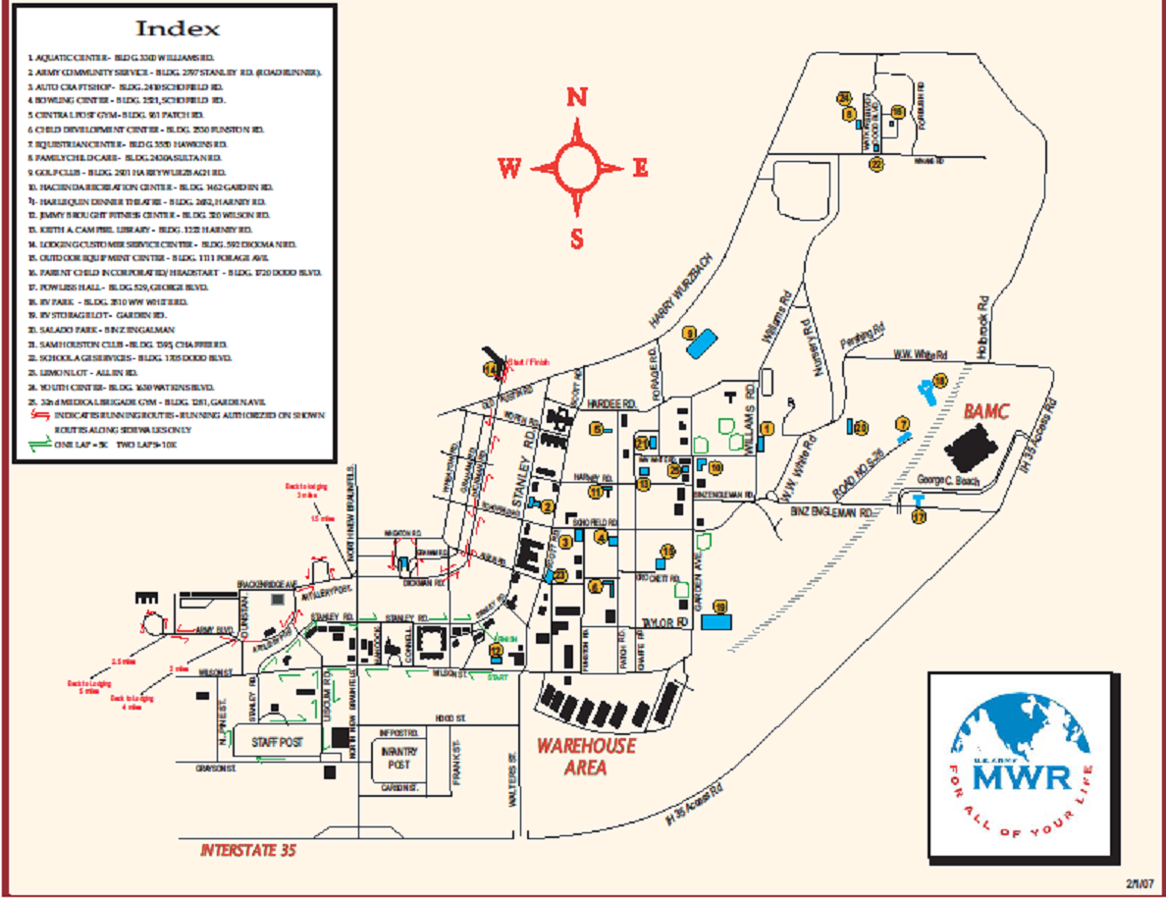

Appendix 2: Continued Service Agreement

Continued Service Agreement
For
Employees Participating in the Army Baylor Master of Healthcare Administration Training Plan
1. I understand that participating in the Department of the Army Master of Healthcare Administration Training Plan creates a service obligation for me. I agree to work for the Department of the Army or another Department of Defense component for the time specified below. If I am involuntarily separated from my job, my service obligation ends.
2. I understand that I can go to work for a Government department or agency other than the Department of Defense before my service obligation ends. I agree to give my employing activity at least 10 workdays' notice if I do transfer outside the Department of Defense. If my training was in a non-Government facility, the Department must decide within the 10-day period if I have to repay the Government the total costs of the program. If I do not give this notice, or if I am notified before transfer that I must repay the costs, I will reimburse the Government the total certified actual costs.
3. I understand that if I break this agreement, the Government may withhold money I owe it from money it owes me. The Government can also recover money I owe it in other legal ways.
4. I understand that this agreement does not in any way commit the Government to continue my employment.
5. Employee's name: _____________________________________
6. Training period (day, month, year)
Starting date ______________________
Ending date ________________________
7. Service obligation period (day, month, year)
Starting date ______________________
Ending date ________________________
Signature of employee: _______________________________
Date: _____________

Appendix 3: Housing Reviews
Name of Complex | Lakeside Villas | Legacy Heights | Cenizo Flats | Villas at Oakwell Farms | Indian Hollow
Address |  | 1320 Austin Hwy | 33 Lynn Batts Ln | 3333 Oakwell Court | 12701 West Avenue,
Travel Miles | 3 miles | 4-5 mi | 3.5 miles | 4 miles | 10 miles
Travel Time | 5min | 5-8 min | 8 min | 10- 15 min | 18 min
Complex Conveniences | gated, 3 pools, well kept, quiet, | covered parking well kept, quiet, gym | gated pool, | Gated, gym, pool, indoor hot tub, covered parking, quiet neighbors | gated, hot tub, pool, dedicated parking area, very beautiful well kept grounds, quiet
Complex Pitfalls | Apt are aged | quite nice overall, no trails. | planes “fitness center" is 3 machines. | planes overhead routinely. Close shops Elementary is next door Great trail is down the road | Quiet. Falling apart. Close to shopping & restaurants, 5 min from airport
Area Conveniences | proximity to FSH | multiple shopping stores and restaurants. | 12 min drive to downtown, close to base, | N/A | N/A
Area Pitfalls | N/A | not sure about school but the area is really quiet | Not a lot of running paths | N/A | N/A
Approx Rent | $700-$750 for one bedroom apartment | from $600 to $1000 | $950 for 2 bed/2bath | $700 per month Complex waives application fee for military | $1005 for 2 bedrooms, 2 bath and a garage
Extra Costs | Utilities | Utilities | Utilities | Utilities. | Utilities
Would you rent here again? | No | love this place and feel very safe here | Yes. | Yes. | No, many issues with my apartment. Put in 25 work orders within the last year.

Appendix 4: Helpful Resources

DFAS Civilian PCS: http://www.dfas.mil/travelpay/civilianpcs/frequentlyaskedquestions.html
Joint Travel Regulations (see volume 2 for civilian regulations): http://www.defensetravel.dod.mil/site/travelreg.cfm

Joint Travel Regulation, Chapter 4, Part K, C4530, paragraph C-D

