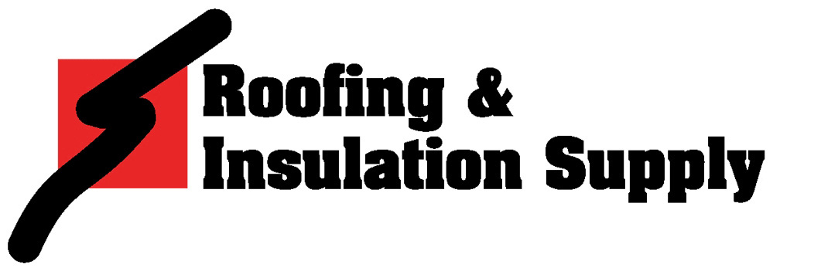
Management Training program

Company Description
Roofing & Insulation Supply (RIS) is a wholesale distributor of roofing, insulation, and related products servicing contractors and building materials dealers nationwide. We have over 20 locations across the Northeast, Mid-Atlantic, Southeast, Midwest, and Southwest regions, and we continue to rapidly grow. We foster this growth by maintaining a high standard of training, building strong customer relationships, and supplying the highest-quality product lines. Our strategic plan has been, and continues to be, building a network of branches across the country managed by a strong core of Regional Vice Presidents.

Opportunity
We are seeking graduating students with a strong sales aptitude, business acumen, and entrepreneurial spirit to enter our Management Training Program. After working hand-in-hand with a Branch Manager for 2 to 3 years during training, the Management Trainee will have the opportunity to establish a RIS branch in a new market location, thus becoming a Branch Manager. As a Branch Manager, the compensation opportunity exceeds $100,000 annually.

Responsibilities
Because our strategic focus is to promote from within, it is necessary for a successful Management Trainee to learn every function of the company, in order to become an effective Branch Manager. This includes purchasing, inventory management, operations, customer service/inside sales, and territory management/outside sales. Throughout training, our Management Trainee work with their Branch Manager to gain a greater understanding of and proficiency in sales management, fiscal responsibility, branch operations, and business development and growth. In addition, successful Management Trainees acquire a firm grasp of the industry, by developing strong relationships with suppliers, as well as working as a consultant with our customers to strengthen and grow their businesses.

Qualifications
Our ideal Management Trainee has excelled academically and demonstrated strong leadership among his/her peers. Strong communication skills are a must, as well as the desire and drive to manage a business.

A successful candidate also possesses the following characteristics:

- High level of initiative - Desire to sell
- Exceptional work standards - Entrepreneurial spirit
- Excellent communication and follow-through - Proficient computer skills
- Outstanding planning and organizational skills - Ability to problem solve in proficient manner
- Able to handle high-pressure situations - Success at building relationships
- Proven leader in classroom, work, and/or social situations

Bachelor’s Degree required

Candidate must be willing to relocate.

Prior knowledge and/or experience in the construction industry is not a necessity.

To start your career with RIS, please visit us online at www.risris.com/Career-Opportunities

