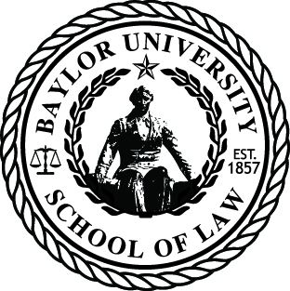
Request for Certification, Deferment Letter or
Verification of Enrollment

Baylor University School of Law
Registrar's Office
1114 S. University Parks Drive
One Bear Place #97288
Waco, TX 76798
Phone: 254-710-1911 Fax: 254-710-2316

Student Information: Certification:

Name ________________________________ **Bar Certification
(Print Name) State _______
Student ID or SSN _____________________
Phone ________________________________ Enrollment Verification
Email ________________________________ Good Standing Verification
School year ________________ (1L, 2L, etc.) Certification of Graduation
Alumni _______________________________ Loan Deferment Letter
Graduation date _______________________

*Signature ______________________________________________________________

Other Certifications (explain):

Detailed Instructions:

Delivery:

Pickup ____________

Mail: Fax:
_________________________________ ______________________________
_________________________________ ______________________________
_________________________________ ______________________________
_________________________________ ______________________________
_________________________________ ______________________________
Please note certifications may take 2 to 3 business days to process.
*Signature Required for Processing. Your signature gives the office the right to release your information to the requesting party.
**Please include this release form with your bar certification forms.

