For Immediate Release

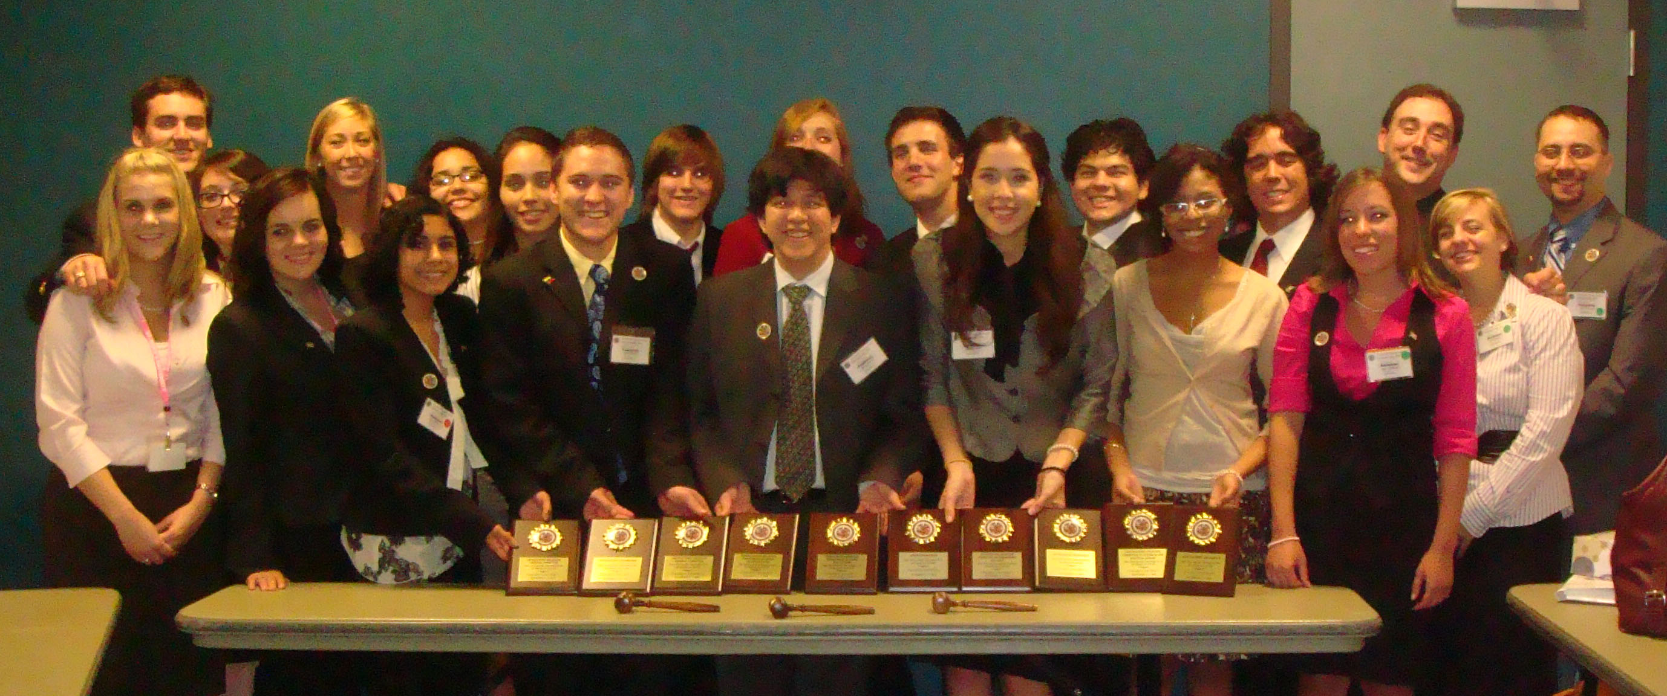

Baylor’s Model Organization of American States Team set a new record for awards received at the recent Model held at St. Mary’s University in San Antonio, Texas. Baylor received the Outstanding and Distinguished Delegation Awards as well as six committee awards, the award for Best Committee Chair, and Outstanding Ambassador Award. The conference held between 5-7 November 2009 was attended by over 200 students from 19 universities (including three from Mexico) representing 24 countries in the hemisphere. Comprised of two delegations representing the countries of Venezuela and Suriname, the Baylor team took the two top awards at the model by winning Outstanding and Distinguished Delegations, respectively. In the General Committee, Head Delegate for Suriname, Daisy Marchena (Senior, International Studies Major from Houston) was awarded Outstanding Delegate while Head Delegate for Venezuela, Tyler Talbert (Senior, International Studies from Waco) won Distinguished Delegate. In the Committee for Juridical and Political Affairs, the Suriname delegation represented by Ally Gutierrez (Sophomore, Political Science from Cypress) and Torie Rhodes (Junior, International Studies from Pasadena, California) won Distinguished Delegation. Hunter Klein, (Senior, Political Science Major from Tomball) was awarded best Chair. In the Committee on Hemispheric Security, the Suriname Delegation composed of Leisel Walters (Senior, International Studies Major from Tegucigalpa, Honduras) and Jenna Thompson (Junior, Journalism and International Studies Major from Indianapolis, Indiana) won the Outstanding Delegation award. In the Department of Trade and Tourism Committee, the Venezuelan Delegation represented by Catherine Gibson (Junior, Latin American Studies Major from Bedford) and Amanda Honey (Sophomore, History Major from Celina) received the award for Outstanding Delegation. In the Inter-American Board for Agriculture, the Suriname Delegation composed of Daniela Romero (Senior, International Studies Major from Mexico City, Mexico) and Rob Bradfield (Sophomore, Theater Performance Major from Waco) won the Distinguished Delegation Award. Venezuelan Head Delegate, Tyler Talbert, won the award for Outstanding Ambassador. The Venezuelan Delegation received the Outstanding Delegation award for their representation of the Venezuelan position in committee and in their position paper and resolutions, while the Suriname Delegation won the Distinguished Delegation Award.

Other members of the Venezuelan Team included: Michael Lyssy (Sophomore, International Studies Major from Falls City), Jimmy Smith (Sophomore, Political Science Major from Rockwall), Daniel Hoover, (Graduate Student, History from Waco), Brittney Quezada (Sophomore, Political Science Major from Houston), Monica Uribe (Senior, Music Performance Major from Harlingen) and Hilary Andrews (Junior, History Major from The Woodlands). Other members of the Suriname Delegation included Kaley Halliday (Senior, International Studies and Spanish Major from South Elgin, Illinois) and Alex Tellez (Senior, History Major from San Antonio).

In addition to their awards, Baylor students also played vital roles in the leadership of the model. Manny Muñoz (Senior, Political Science Major from San Antonio) served as president, Renee Sanchez (Senior, Spanish Major from Brownsville) was the model’s Parliamentarian, and Joshua Hyles (Graduate Student, History, Mabank) sat on the Steering Committee. At this year’s model, Michael Lyssy was elected next year’s president making the third year in a row that a Baylor student will serve in that position. Brittney Quezada was appointed by a faculty committee to serve as Assistant Parliamentarian for the 2010 model.

The Baylor Model Organization of American States Team is coached by Dr. Joan Supplee from the Department of History.

For more information please contact:
Dr. Supplee at: Joan_Supplee@baylor.edu
Joshua Hyles at: Joshua_Hyles@baylor.edu
Manny Muñoz at: Manny_Munoz@baylor.edu
Renee Sanchez at: Renee_Sanchez@baylor.edu
Hunter Klein at: Hunter_Klein@baylor.edu
Michael Lyssy at: Michael_Lyssy@baylor.edu

